Mary Mattingly Owns Up
Viewing Guide & Word Bank
Instructions: View and listen carefully, answering the following questions as you view the video clip. A “Word Bank” with definitions of important words used in the video is on the back of this sheet.
1. In what city is this video taking place?

2. Where is Mary Mattingly going with her ball of objects?

3. How many personal objects has Mary Mattingly documented so far?

4. Why does the artist say it is traumatic for her to display her high school diary?

5. Why is she embarrassed about the objects in Fill (Obstruct)?

6. What kind of research does the artist do for each of the objects?

7. The artist says that the project started as a “personal exploration,” but now it is more than that. What does she hope her art will accomplish?

8. Do objects come with responsibility? What is your responsibility to the objects you own?

Word Bank
(vocabulary is listed in order of appearance on video, from left to right)

Security checkpoint: a place where only certain people have permission to enter  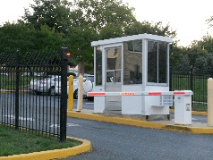  Image source: https://pnwtransplant.wordpress.com/2011/08/17/goodbye-baltimore/ | Altercation: a noisy argument or disagreement  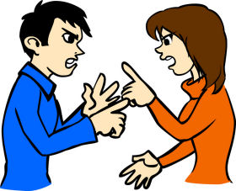  Image source: http://askjoshsmom.com/communication-or-altercation/
Amused: something that makes you want to laugh or smile  Image source: http://www.clipartkid.com/amused-cliparts/ | Environment: the world around you, especially where you live  Image source: http://drexel.edu/now/archive/2013/June/Neighborhood-Features-Could-Prevent-Obesity/
Mass production: making something in large quantities, often with machines  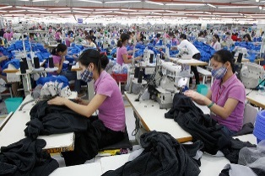  Image source: http://www.manager.co.th/Indochina/ViewNews.aspx?NewsID=9570000011338 | Obstruct: to stop or block  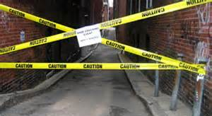  Image source: http://www.dixinary.com/dictionary/obstruct
Consolidate: gathering up many small things into one large group  Image source: http://web.stanford.edu/dept/CTL/cgi-bin/academicskillscoaching/using-your-notes/consolidate/ | Traumatic: an experience that is upsetting or hurtful  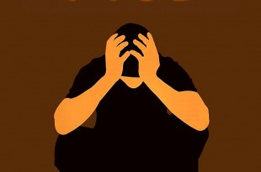  Image source: http://anxietynetwork.com/post-traumatic-stress-disorder
Embarrassing: something that makes you feel ashamed  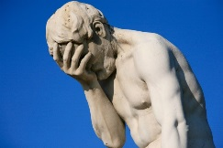  Image source: http://tweetpeepz.com/embarrassing-moment-life-best-answers-quora/ | Research: to study something deeply  Image source: http://innovationexcellence.com/innovation-research/
Supply chain: the steps it takes to make a product and get it to consumers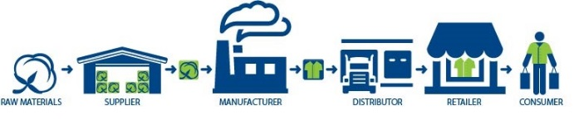  Image source: https://www.swtc.edu/academics/programs/business/supply-chain-management | Responsibility: your job or duty and the decisions you make about it  Image source: http://alearningaday.com/2016/07/when-is-it-your-responsibility/

